IFG Adventure – 2nd Year

Term Two, Week One: Mothers Day

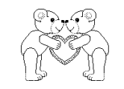
Aim:
To teach the girls that their mums and grandmas are very special people. God wants us to be thankful for our mothers and grandmothers and honour them by showing them how special they are and obeying them.

Objectives:
- To have the girls decorate a cushion cover or pillowcase with the assistance of grandmothers.
- To learn the history of Mothers Day
- To learn and play games from grandmothers’ childhood.

Coaches Tip: Be aware of any girls in your unit who do not have a grandmother. She may have another adult female she can bring to this week. Some of the women of your church may also offer to help out in these situations.

Preparation:
- Decorate a cushion cover or pillowcase as an example.
- Have a notice for girls including an invitation to grandmothers to attend the first week, and for the girls to bring along a plain coloured cushion cover or pillowcase, which can be decorated.
- Ensure you have enough rickrack braiding (80cm for each flower) for girls to make at least one flower each.
- A variety of buttons for the girls to choose from.
- Matching thread and enough sewing needles for each girl.
- Ensure you have the right equipment for the older style of games.

Pre Setup:
Before girls arrive set up materials on a table for cushion cover or pillowcase makeover.
Also, as much as possible set up equipment for the games.

SetUp:
This is your usual formal start to the evening programme; girls will assemble at the Home Zone for marking the roll etc.

Devotion:
Soon we will be celebrating Mothers day. This is a special day to show our mums how much we love them! The Bible has a lot to say about our mums.
"We were gentle among you, like a mother caring for her little children.
"1Thessalonians 2:7
Lesson: Mothers care for you and are the ones who tell you what to do or not to do in order to help you develop good habits.

Outline:
Introduce reel of thread:
1. Good habits: Our mothers keep telling us to do things because the more we do them; the more likely we are to continue doing them.
2. Bad habits: Our mothers remind us to stop doing things we should not do.
- God has given our mothers a huge responsibility.
- Conclusion: This Mother's Day let’s all decide to help our mothers with the job God wants them to do.
I will need a volunteer.
Do you think you are strong enough to break this thread? I'm going to wrap it around your wrists once or twice.
Yes, that was easy to break. This time I am going to wrap it several times. I see you had to struggle to break the thread that time.
Do you always do what your mother tells you to do? Each time she reminds you to do something and you obey her, it is like wrapping this thread around your wrists again and again (wrap as you talk). Let's take an example. Every night your mother will remind you to say your prayers. The more you do this, the more likely you will be to remember to do this by yourself. Soon you have formed a good habit.
Now try to break the thread. You seem to be having a little trouble. A few threads were easy to break but with lots of thread you have become really tied up. Go back to your seat now and I'll check with you in about an hour to see how you are doing.
Your mother sees to it that you do the right thing many times because she wants you to develop good habits.
Your mother also stops you from doing or saying the wrong things. She knows that bad habits are even easier to make and harder to break. The more you do something wrong the less it seems like the wrong thing to do. Have you ever lied to your mother about something you have done so that she would not punish you for it? Be careful! You know it is wrong, but the more you do it the easier it becomes. Soon she will not be able to trust you.
God has given your mother the task of helping you make good habits and avoid bad habits. That is quite a responsibility!
This Mother's Day is a good time for you to decide to help your mother with this tough job.

Prayer:
Dear God, Thank you for picking just the right mum for me. Thank you that she helps me learn about you. Please help me to make her happy by listening to her and doing what she says. Help me to make her feel special today and every day. In Jesus’ name. Amen

Activity Session:
Activity one -
Here is an interesting grandmother/child game idea which can be played.
Steps
- Divide into grandmother/child teams.
- Ask the grandmothers to leave the room while the children sit in chairs.
- Ask the same four or five questions to each child about their grandmothers.
- Bring in the grandmothers and ask them the same questions.
- Will the grandmother and child have the same answers?
- Switch places and see how well the grandmother's know the children.
- Award a red carnation to the winning grandmother/child team.
Sample Questions:
Favourite color, movie, dress, animal, memorable moment with you, best friend, hobby, talent, food, animal, cartoon, pizza topping, ice cream topping, restaurant. Favourite holiday.

Activity Two:
Games of Yesteryear
Choose two or three
Skipping was a game, either for an individual person or in a group where the ends of a longer rope were held by two different people. Any number of children could come in and skip together. Sometimes we would play at "calling in" a particular child by name and we would vary the speed of the rope so that the child doing the jumping had to jump faster or in some sort of fancy manner.
Leapfrog. One or more of us would bend over and clutch our knees while the others would run and put their hands on our backs and jump over. Sometimes we would get a clout on the head if they missed.
Marbles, and if there was a manhole cover, they would use the two dips in them that were there for the workmen as gulley’s. I dread to think what their nails were like but hygiene was not as important then as now.
Spinning Tops, peg tops for boys, smaller tops for girls, and whipping tops for everyone, all beautifully made of boxwood. The peg tops were made of ordinary wood about 2 inches long and about 1 ½ inches in diameter, and the sides were grooved. A length of string 90 to 100 cm long which was wound round the grooves. Then, keeping hold of the string, it would be thrown onto the pavement with a brisk jerk. This sent the top spinning on its metal.
Hoops. There were wooden ones in various sizes for girls with sticks to beat them along the pavement. The boys had iron hoops. They would start the hoops with their hands then run with them, using a sort of large hook to keep the hoops going.
Cricket, the lamp post was the wicket. Lamp posts were short and rather elegant, and not automatically controlled.
Hopscotch, The concrete paving slabs of the pavements could easily be marked out with chalk for hopscotch. There were many variations with different rules about what to do at each slab. Hopscotch always seemed to be a game for girls where I lived.
Hide and seek had to be behind people’s privet hedges because the street provided little else to hide behind.
Conkers was an autumn game. As the conkers fell off the horse chestnut trees, boys would select the firm ones and bore a hold into them. Then they would thread their conkers onto pieces of string about a foot long. Conkers was played in pairs, and the idea was to swing your conker to hit the opponent’s one.
Tip - The games you choose will need to be suitable for Grandmothers as well as the girls. Have fun!

Teaching Session:
Explain to the girls that they are going to decorate the cushion cover or pillowcase with the help of their grandmothers.

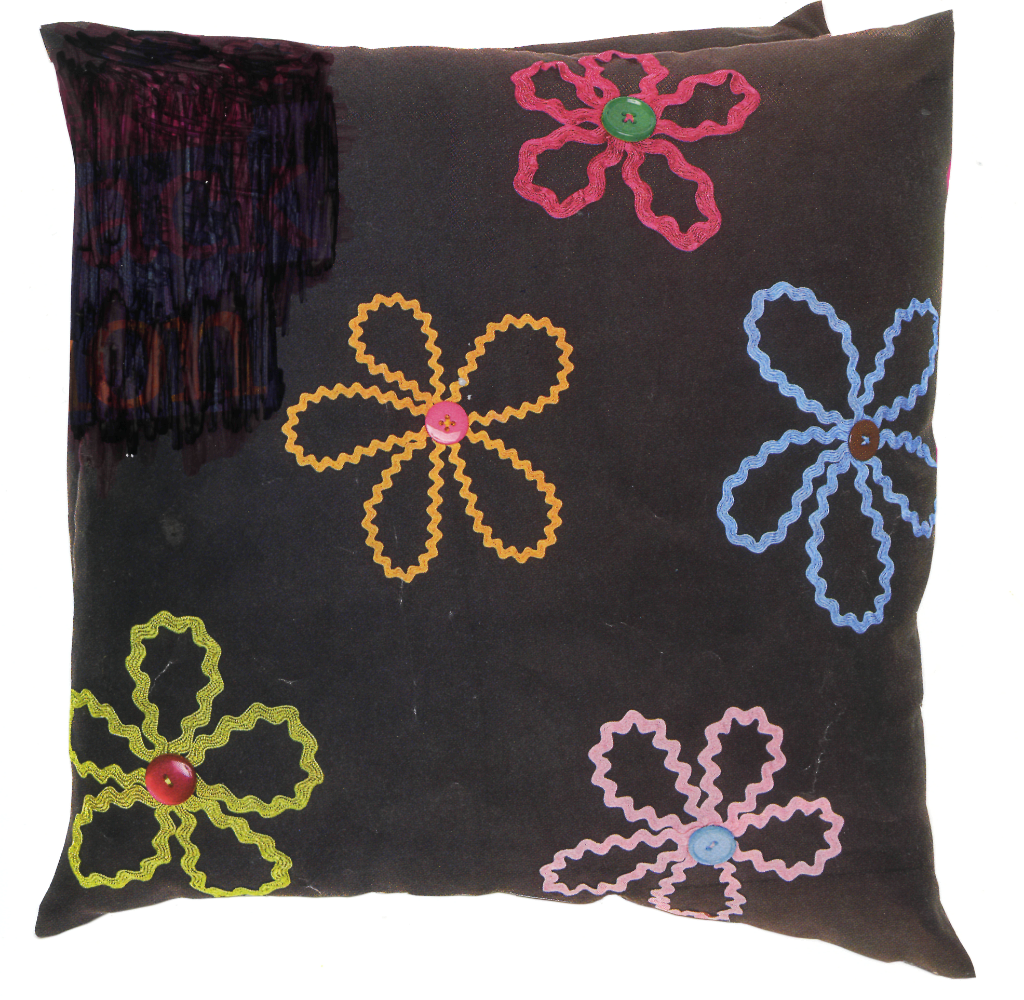

Rickrack flower cushion cover
Equipment needed:
- Cushion cover or pillowcase.
- Rickrack braiding in 80cm lengths in several colours.
- Assorted buttons.
- Matching Thread and needles.

Quantities required will depend on number of girls and numbers of flowers

Instructions
- Using the picture as a guide, fold a length of rickrack into a simple flower shape.
- Start and finish at the centre of the flower and use pins to hold the petals in place on the cushion cover until you are ready to sew.
- You can use one long length of rickrack or a separate short length for each petal, if you find that easier.
- Using small stitches, sew the petals in place, then sew a contrasting button in position at the centre to hide the ends.

Repeat this process for as many flowers as you need, making sure you use matching coloured thread for each. Tie off and trim any loose ends of cotton.

Hint – If you find it tricky to keep the petals in position, use a small amount of appliqué glue.

Prayer

Notices & home time:

Hand out the notice you have written explaining what will be happening next week.
Make sure all the girls are reminded to give them to mum.

